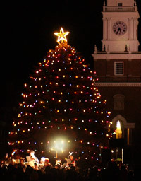

Town Hall Osborne Room, 345 Main Street, Norwell MA

7:00 Executive Session – Land Acquisition and Contract Negotiations–Norwell Farms

7:30 Call to Order/Pledge of Allegiance

Approval of Agenda

Reports
- Citizen Comments
- Selectmen’s Reports and Announcements
- Town Administrators Report

Discussion/Action Items
- 7:35 - Public Hearing – Tax Classification Hearing
- 8:00 - Public Hearing – McLaren Boston, Motor Vehicle Class 1 Application
- 8:15 – Library Town Hall Study Committee Update
- Callie’s Miracle Run Request
- Website Design Discussion

Licenses and Permit

Approval of Minutes

Correspondence

Adjournment

Executive Session – None

